**Name:Vasavi S Puranik**

**USN:1BM24CS320**

**1.Create the above tables by properly specifying the primary keys and the foreign**

**keys.**

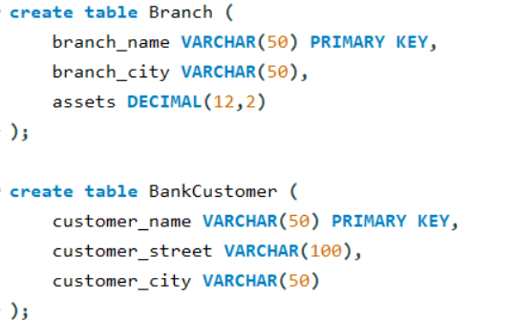

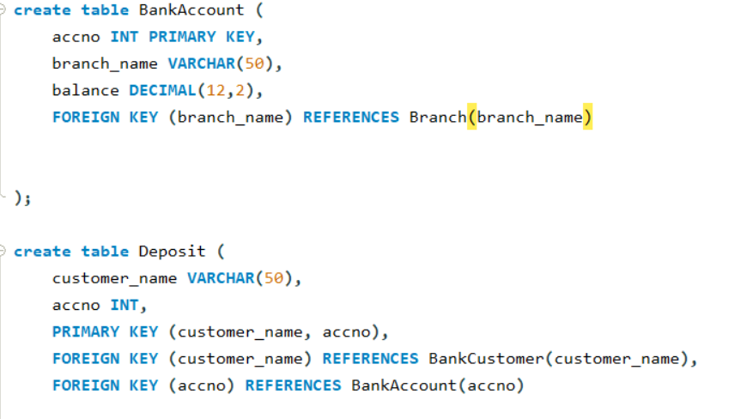

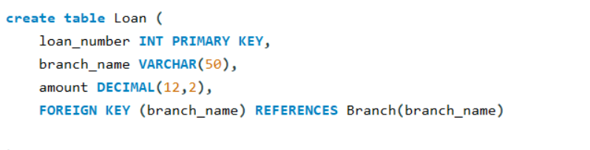

**2.Enter at least five tuples for each relation.**

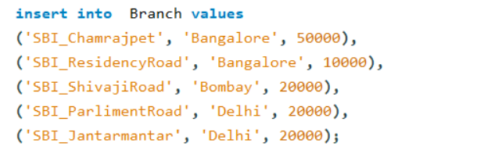

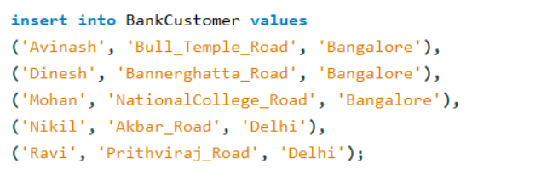

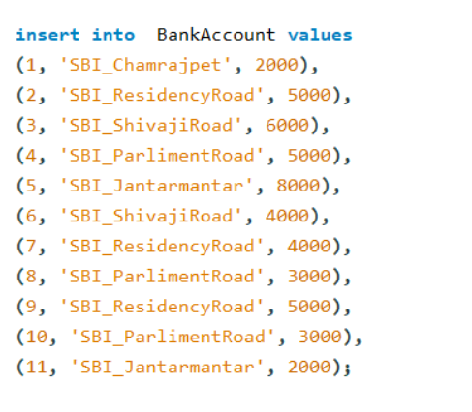

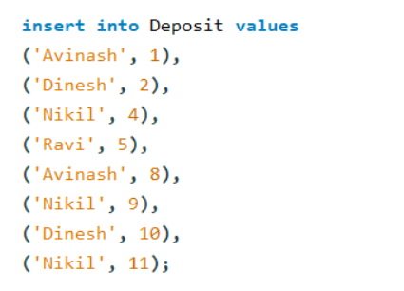

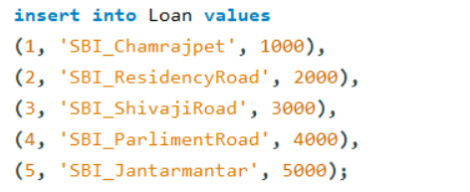

**3.Display the branch name and assets from all branches in lakhs of rupees and rename the assets column to 'assets in lakhs'.**



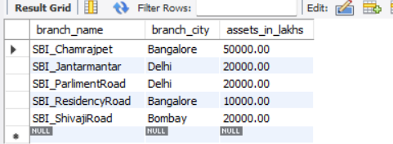

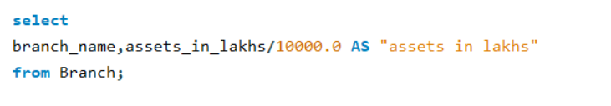

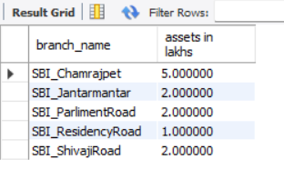

**4. Find all the customers who have at least two accounts at the same branch (ex.**

**SBI_ResidencyRoad).**

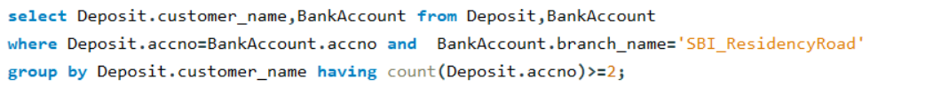

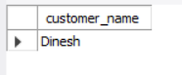

**5. CREATE A VIEW WHICH GIVES EACH BRANCH THE SUM OF THE**

**AMOUNT OF ALL THE LOANS AT THE BRANCH.**

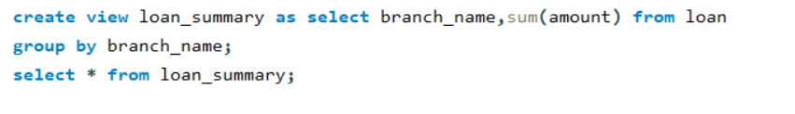

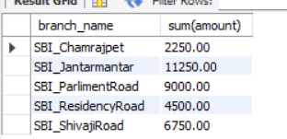

**MORE QUERIES ON BANK DATABASE**

**1.Find all the customers who have an account at all the branches located in a specific city (Ex. Delhi)**



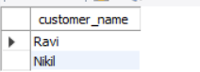

**2. Find all customers who have both an account and a loan at the Bangalore branch.**



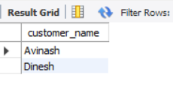

**3. Find the names of all branches that have greater assets than all branches located in Bangalore.**



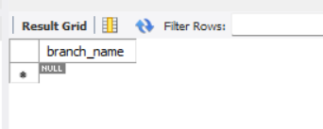

**4. Demonstrate how you delete all account tuples at every branch located in a specific city (Ex. Bombay).**

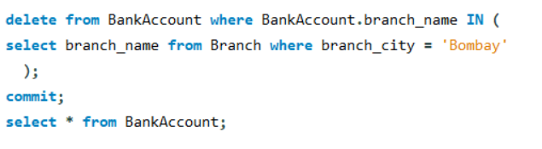

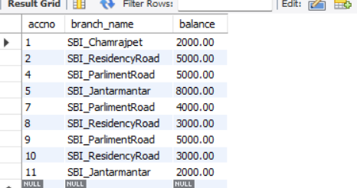

**5. Update the balance of all accounts by 5%.**



